**QR Codes**

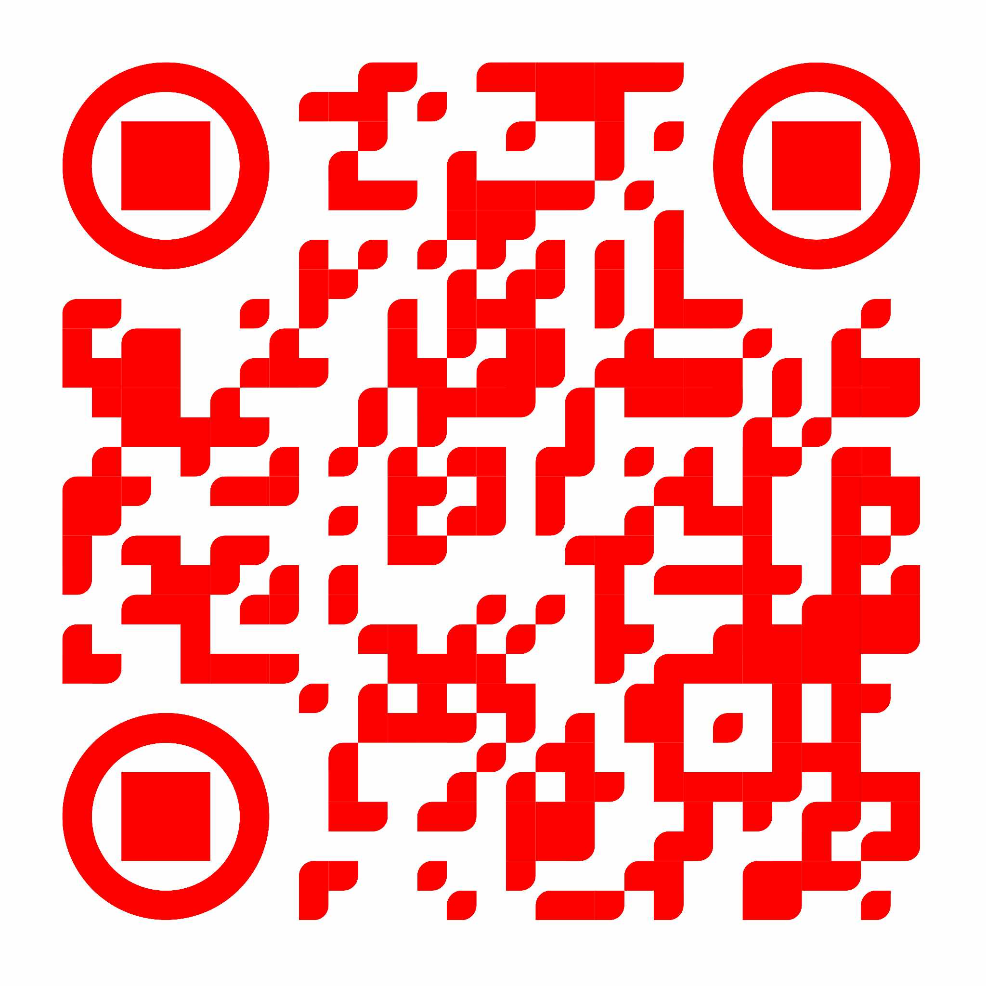**LEVEL 1:**

**LEVEL 2:**



**LEVEL 3:**



**LEVEL 4:**



**LEVEL 5:**



**INSTRUCTION:**

1. 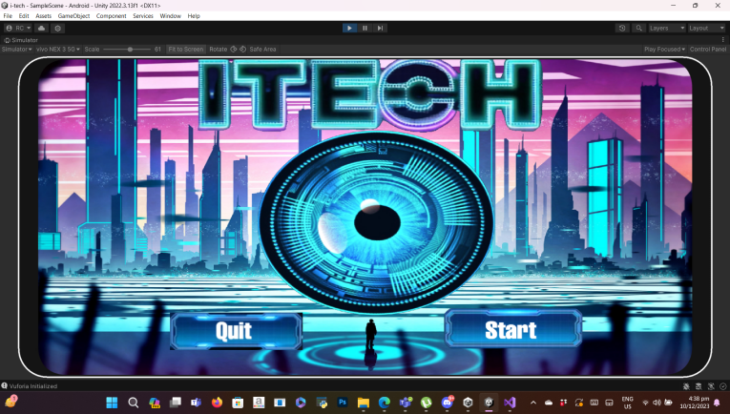**Start game.**
2. 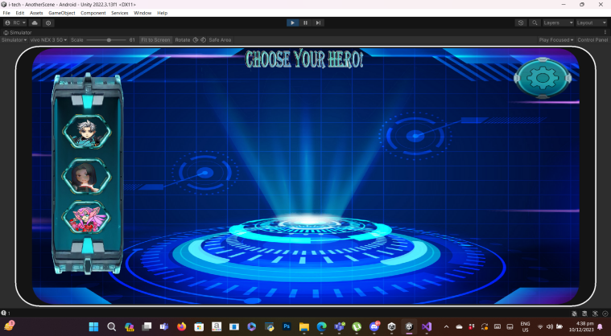**Choose your character.**
3. **Scan the ground plane and wait for the plane indicator.**

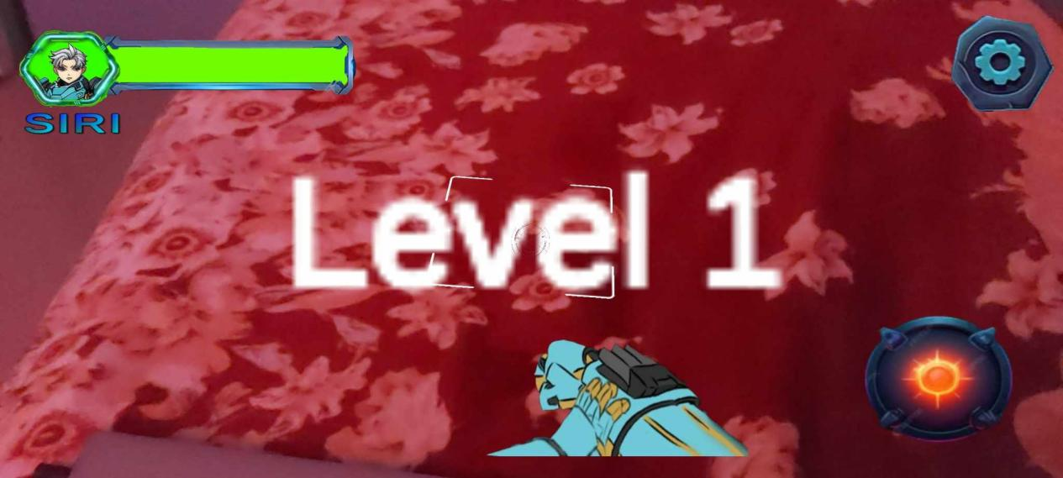

1. **Scan the qr code level 1. (scanning qr code by level)**
2. **Enemy will spawn and you will fight them.**

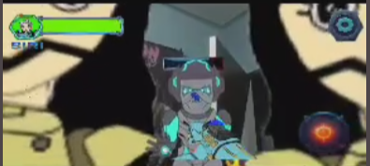

1. 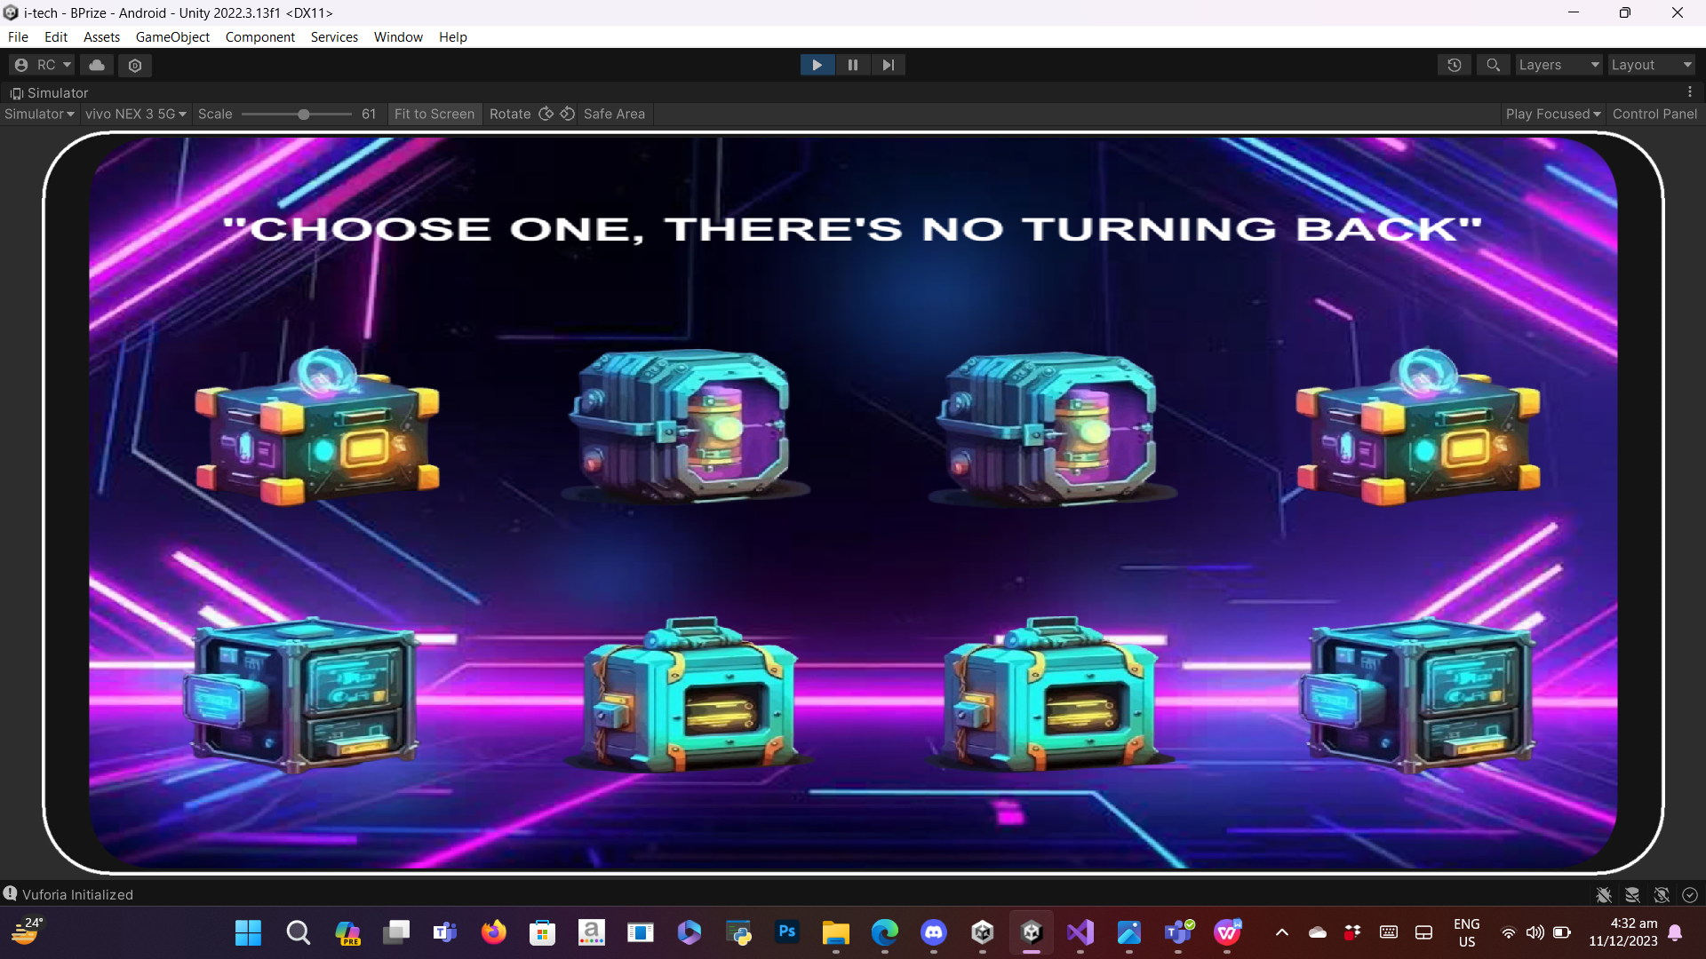**Clear the level 5 and gain victory! And you can get your rewards!**